**ADMIN LOGIN**

**1. Click the login button.**



**2. Enter your login credentials: username and password.**

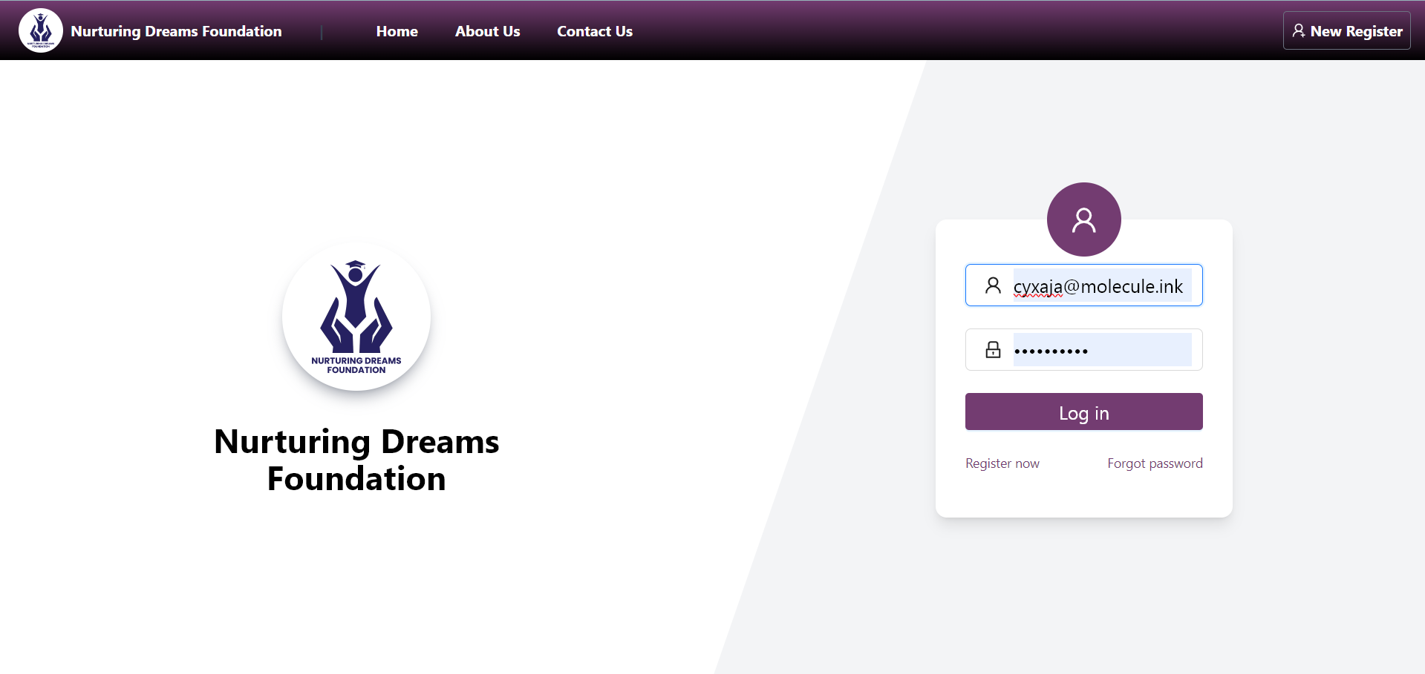

**3. This is the dashboard where you can see the counts for all application statuses, including scholarship and loan applications.**

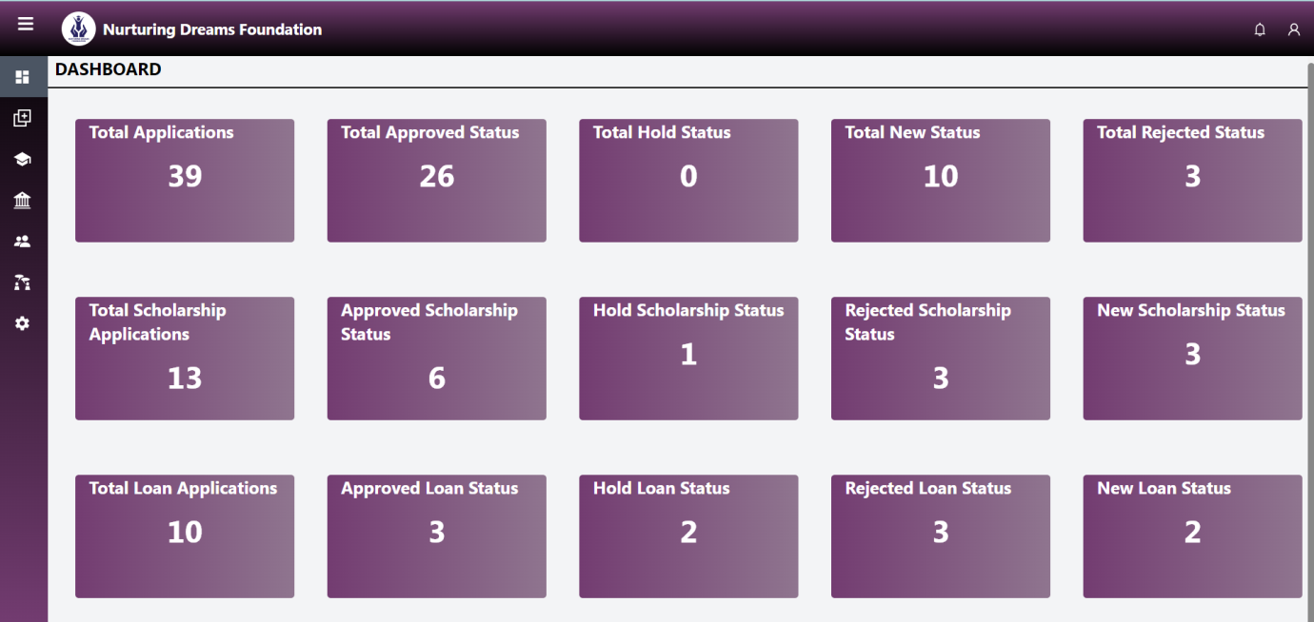

**4. In the upper part, select the "User" option to take action on user applications (approve, reject, or hold).**

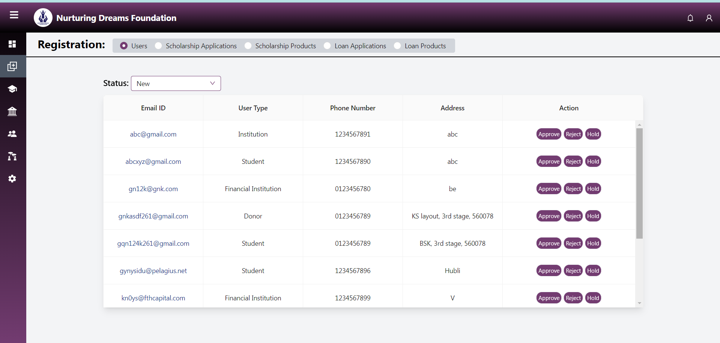

**5. In the upper part, select the "Scholarship Application" option to take action on scholarship applications (approve, reject, or hold).**

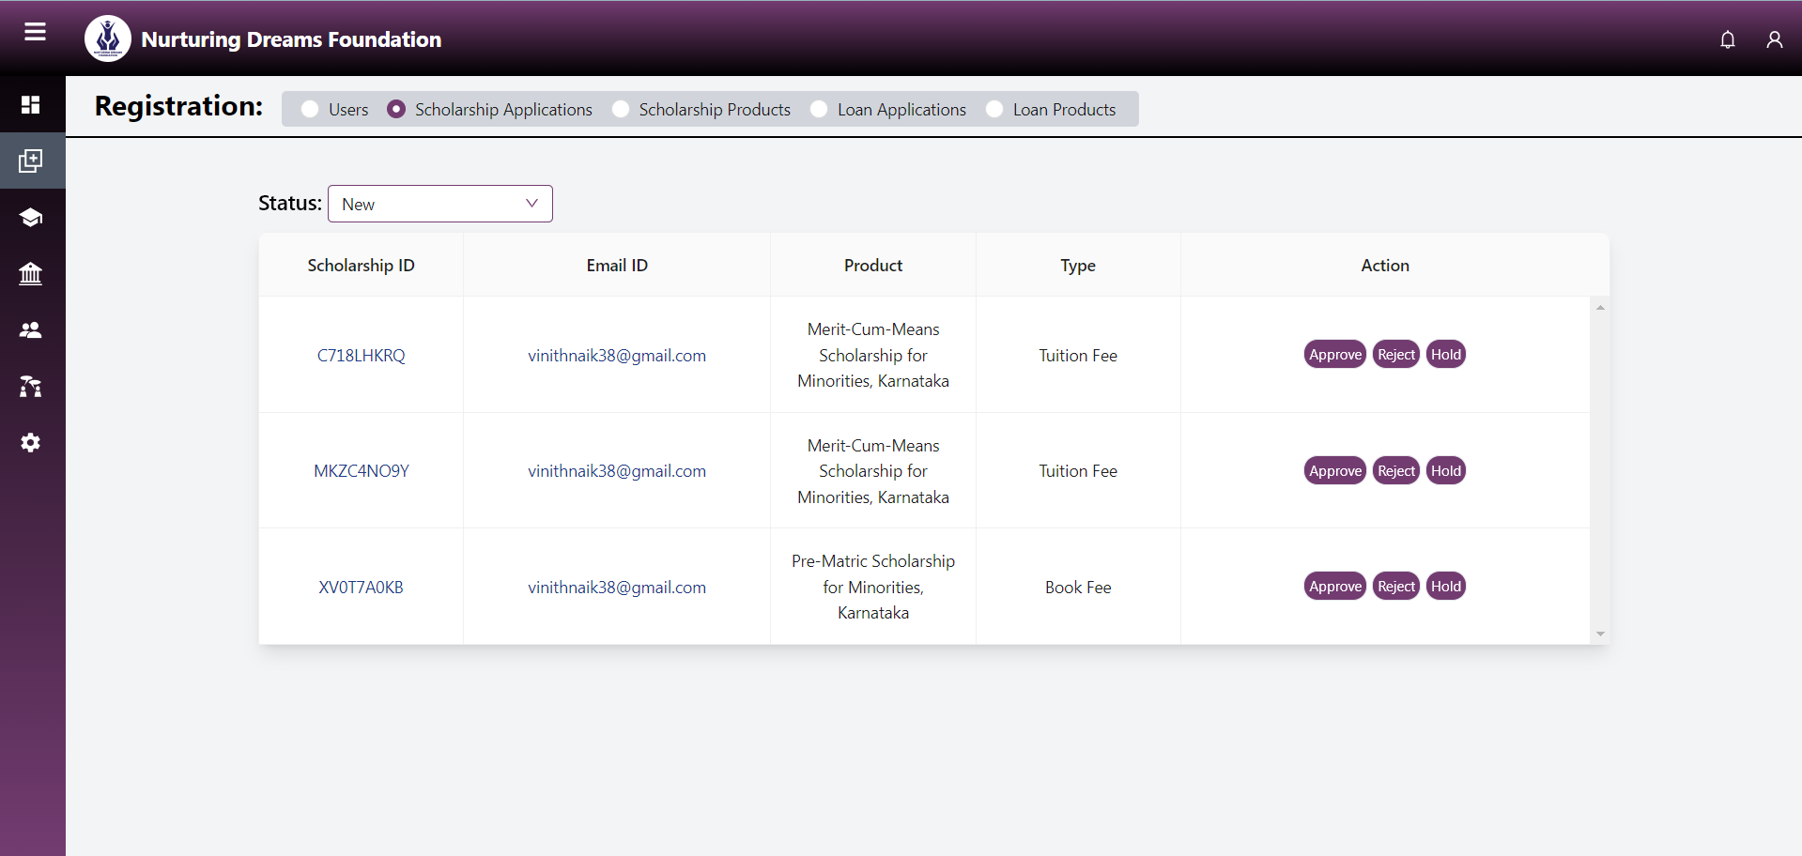

**6. In the upper part, select the "Scholarship Product" option to take action on scholarship products (approve, reject, or hold).**

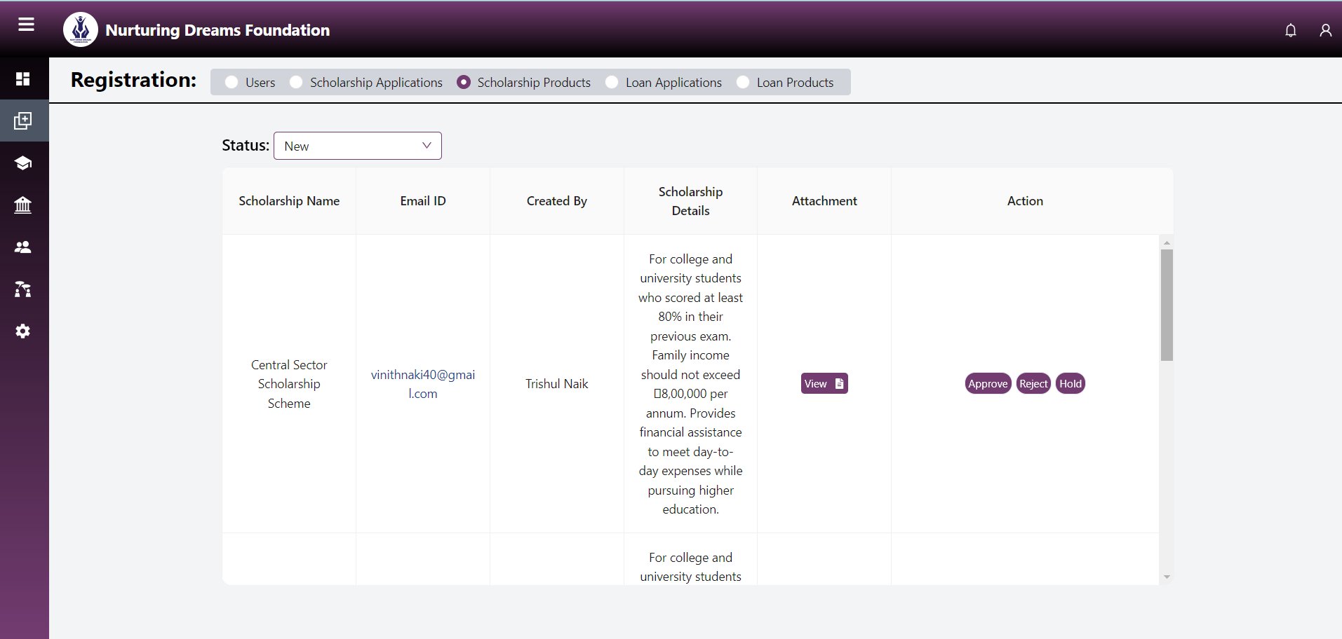

**7. In the upper part, select the "Loan Application" option to take action on loan applications (approve, reject, or hold).**

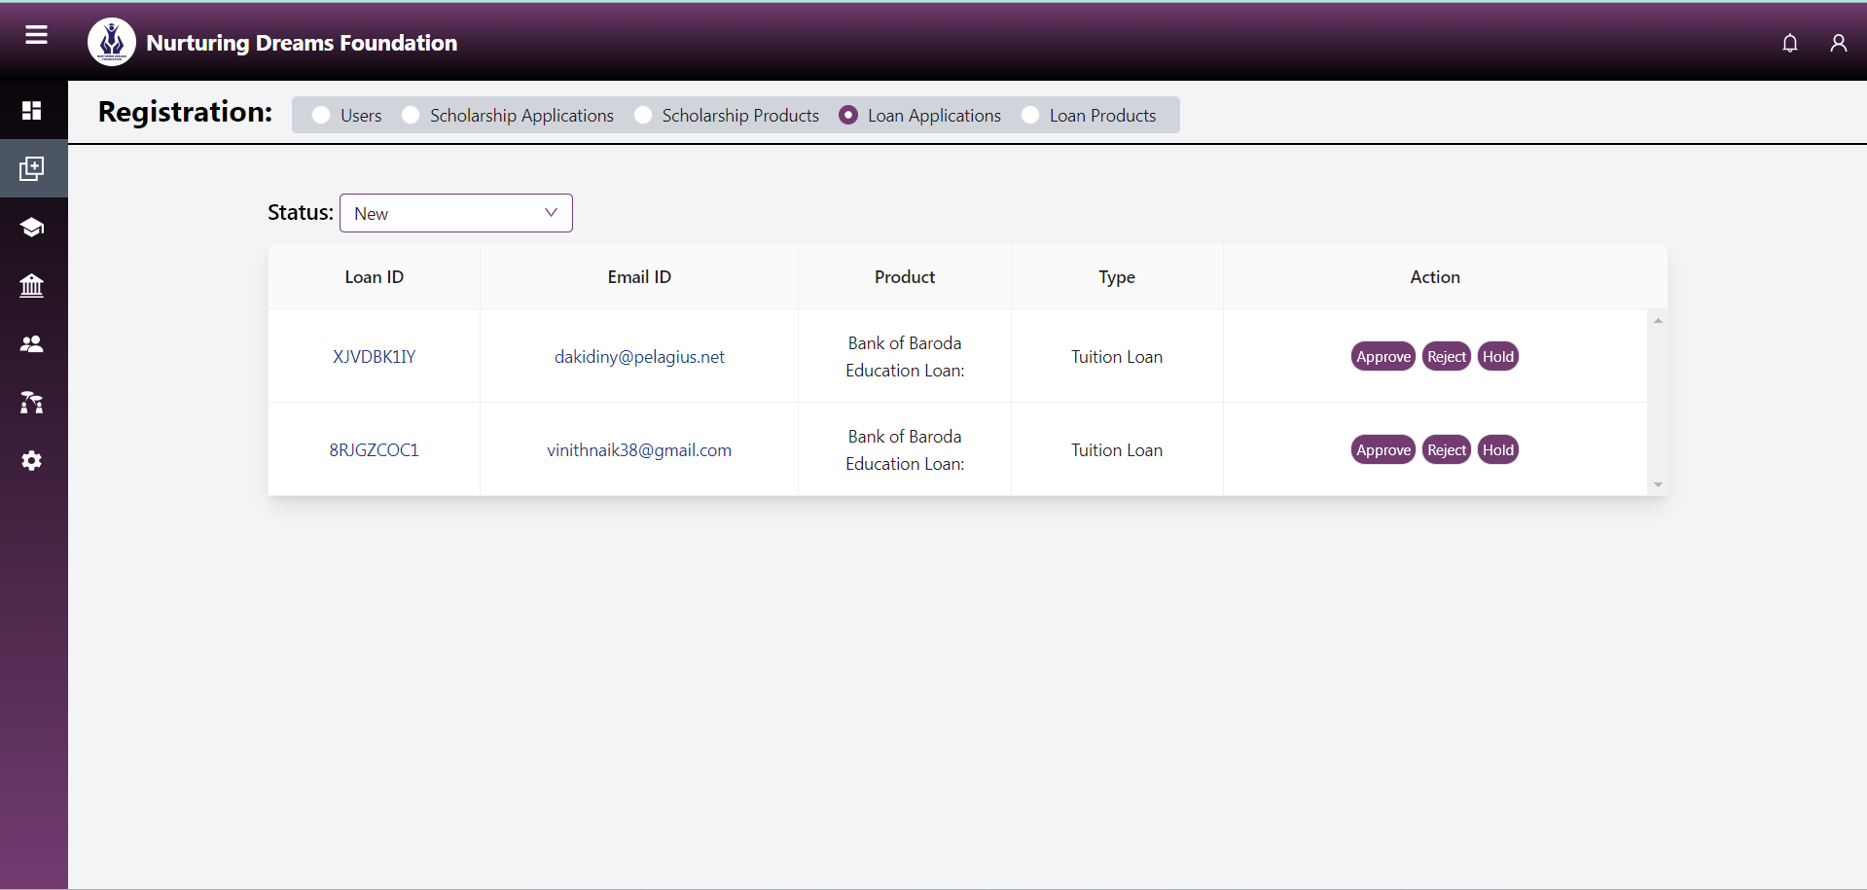

**8. In the upper part, select the "Loan Product" option to take action on loan products (approve, reject, or hold).**

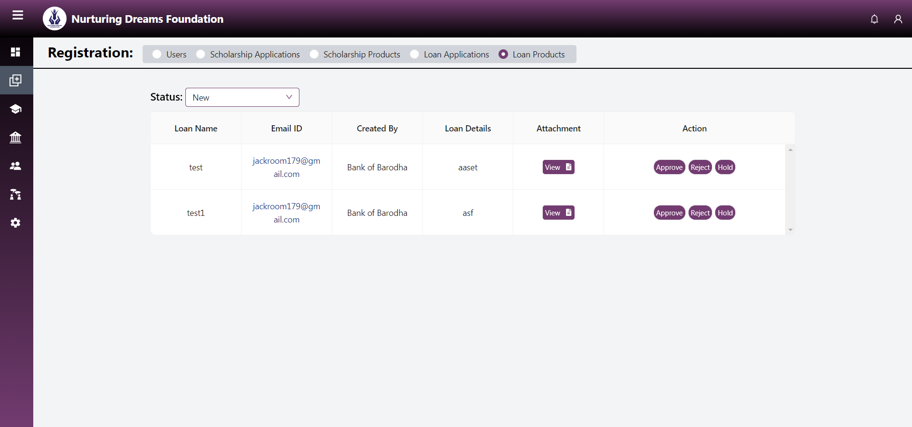

**9. When taking actions like approve, reject, or hold, you can add remarks.**

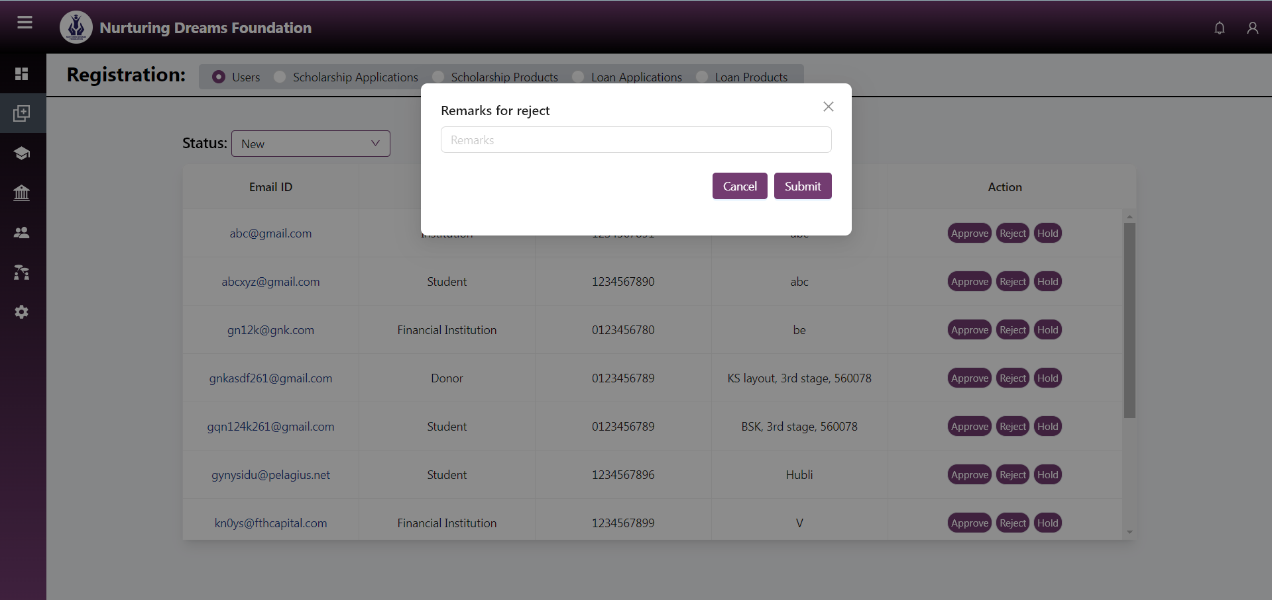

**10. Here you can see a list of scholarship applications with their status.**

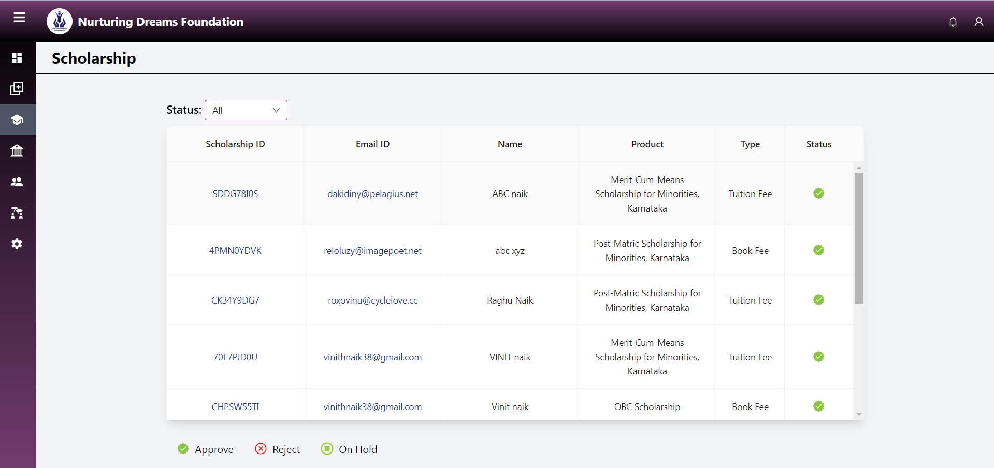

**11. Here you can see a list of loan applications with their status.**

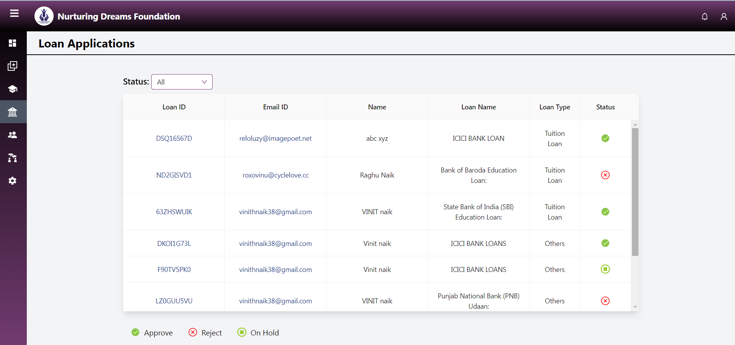

**12. Here you can see all the application details for approved users.**

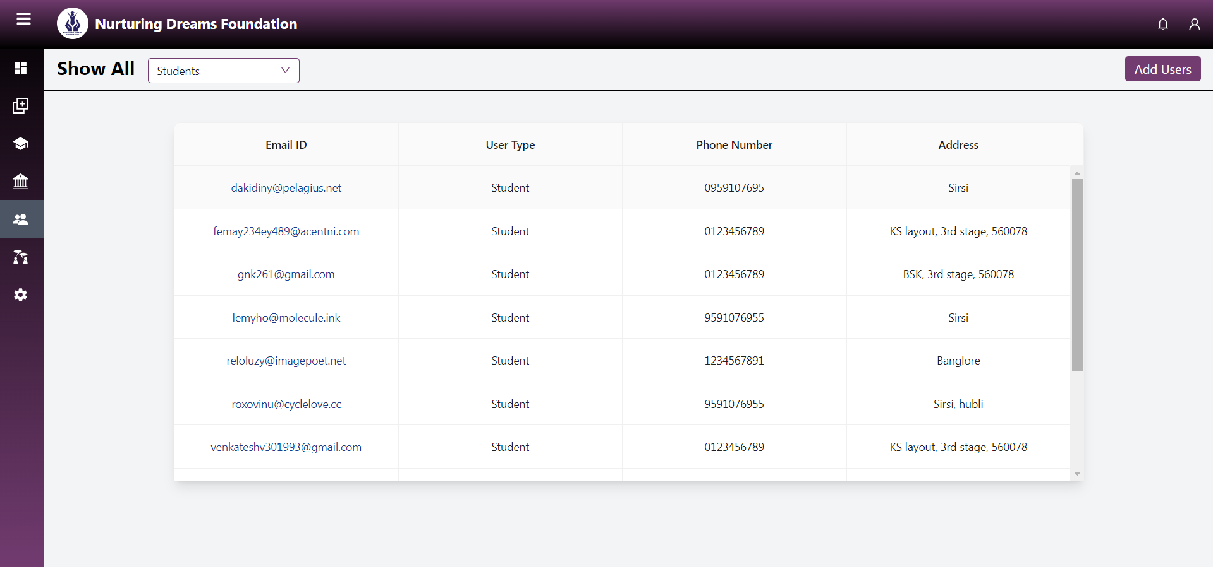

**13. In the top right corner, there is an "Add User" option. By selecting this, you can add users to the platform without any fees.**

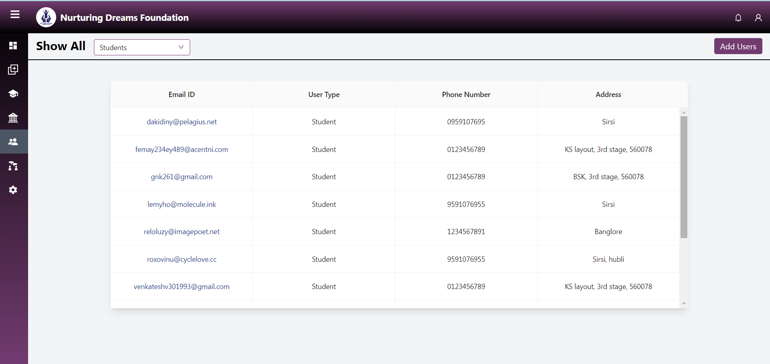

**14. Select the user type and add the user.**

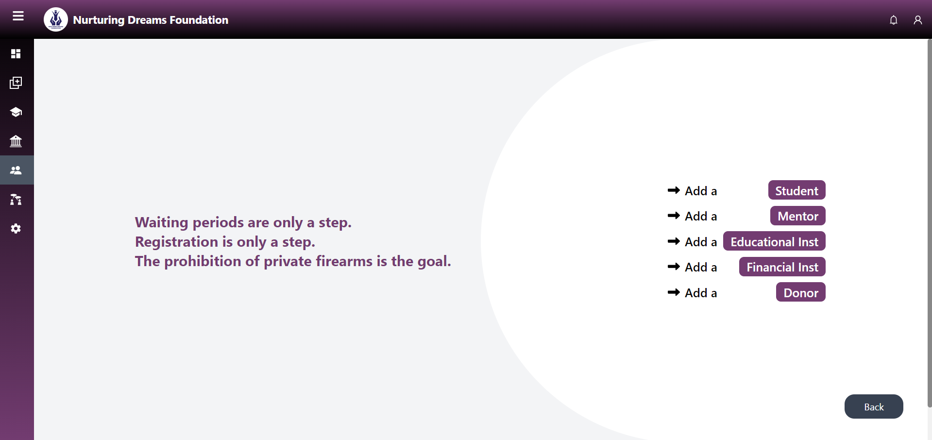

**15. This is the discussion forum where you can chat and create new discussion topics.**

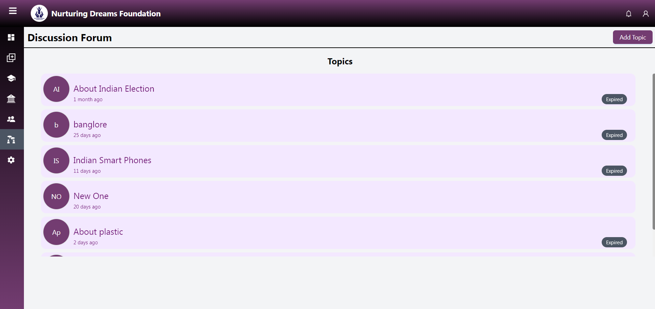

**16. By selecting the "Add Topic" button, you can add new topics for discussion.**

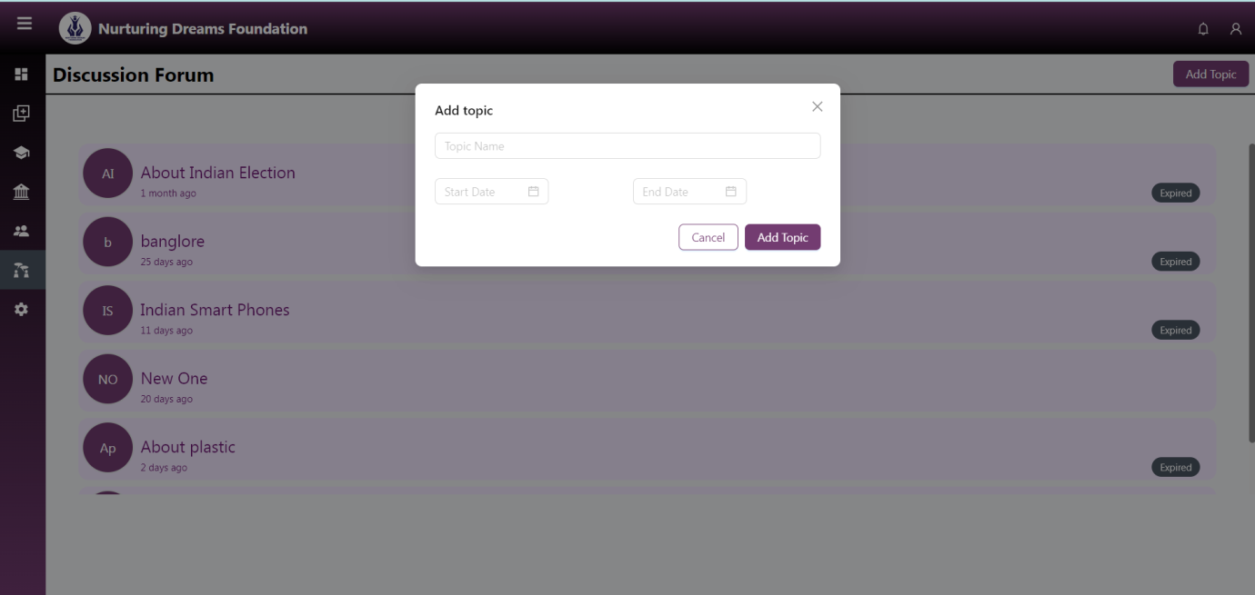

**17. Sample example**

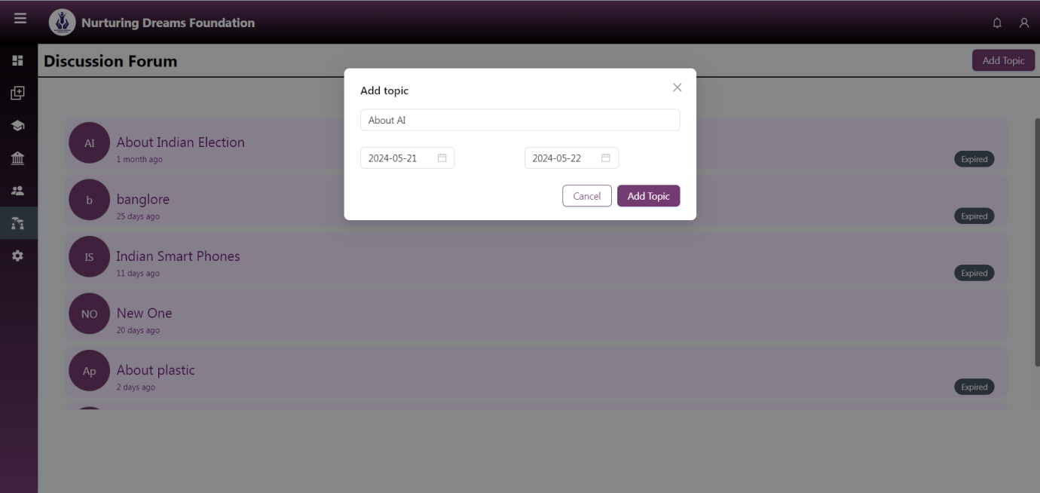

**18. Here the new topic is created and ready for discussion.**

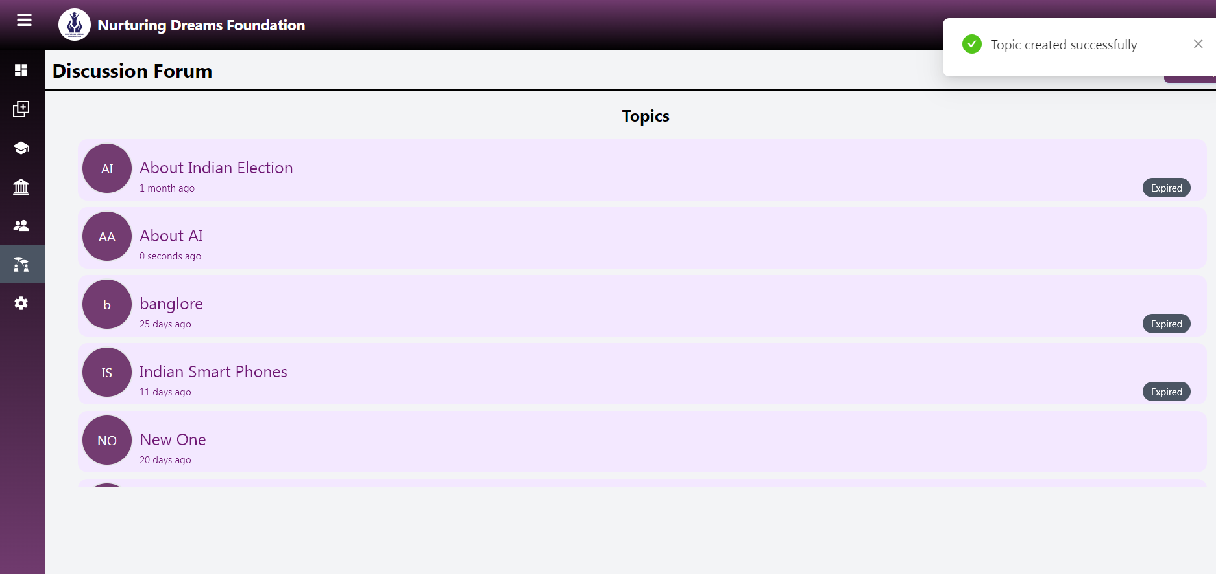

**19. You can reset your password.**

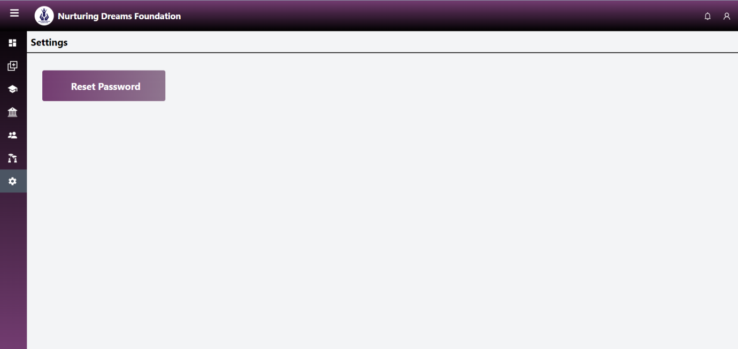

**20. After resetting, you will be logged out automatically. Log in again with the new password.**

